Severe Weather Guide for Long Island

WATCH = Be alert!

WARNING = Take action !



SEVERE THUNDERSTORMS
- HAIL - ball of ice that falls from a cumulonimbus cloud/thunderstorm
  - Penny = 3/4 inch
  - Nickel / Mothball = 0.88 inch
  - Quarter = 1 inch
  - Half Dollar = 1.25 inches
  - Walnut / Ping Pong = 1.50 inches
  - Golf Ball = 1.75 inches
  - Tennis Ball = 2.5 inches
  - Baseball = 2.75 inches
  - Grapefruit = 4 inches
- SEVERE THUNDERSTORM - a thunderstorm which produces
  - hail 1 inch or greater
  - winds greater than 58 mph (50kts)
  - damage to trees, telephone/utility poles or any structure
  - tornado
- SEVERE THUNDERSTORM WARNING - issued by your local NWS Forecast Office when severe weather is imminent or occurring. A warning is issued for a county or part of a county and is usually in effect for about an hour.
- SEVERE THUNDERSTORM WATCH - issued by the Storm Prediction Center when severe thunderstorms are possible in and near the watch area (box). The watch is issued for a large area and is usually in effect for several hours.
Thunderstorms affect relatively small areas when compared with hurricanes and winter storms. The typical thunderstorm is 15 miles in diameter and despite their small size, ALL thunderstorms are dangerous! lasts an average of 30 minutes. Of the estimated 100,000 thunderstorms that occur each year in the United States, about 10 percent are classified as severe.

How does a thunderstorm form?
Every thunderstorm needs:
  - Moisture - to form clouds and rain.
  - Unstable Air - relatively warm air that can rise rapidly.
  - Lift - fronts, sea breezes, and mountains are capable of lifting air to help form thunderstorms.

Life Cycle of a Thunderstorm

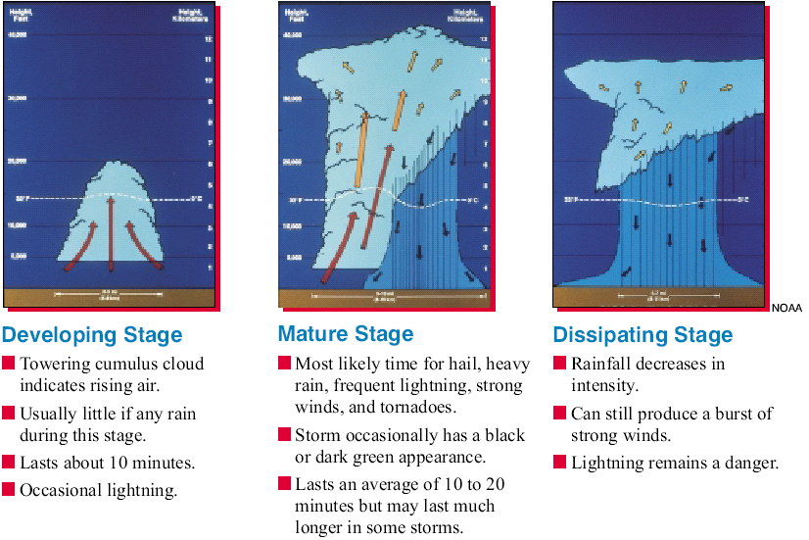

How do I know when a thunderstorm is about to occur?
When skies darken or thunderstorms are forecast, look AND listen for
  - Increasing wind.
  - Flashes of lightning. (To estimate the distance in miles between you and the lightning flash, count the seconds between the lightning and the thunder and divide by five.)
  - Sound of thunder.
  - Static on your AM radio.



What is Lightning?
The action of rising and descending air within a thunderstorm separates positive and negative charges. Water and ice particles also affect the distribution of electrical charge. Lightning results from the buildup and discharge of electrical energy between positively and negatively charged areas. Most lightning occurs within the cloud or between the cloud and ground.
  - The average flash could light a 100-watt light bulb for more than 3 months. The air near a lightning strike is heated to 50,000øF hotter than the surface of the sun! The rapid heating and cooling of air near the lightning channel causes a shock wave that results in thunder.
  - Your chances of being struck by lightning are estimated to be 1 in 600,000 but could be reduced by following safety rules. Most lightning deaths and injuries occur when people are caught outdoors. Most lightning casualties occur in the summer months and during the afternoon and early evening.
  - Many fires in the western United States and Alaska are started by lightning. In the past decade, over 15,000 lightning-induced fires nationwide have resulted in several hundred million dollars a year in damage and the loss of 2 million acres of forest.
Remember the Golden Rule: If you can see lightning or hear thunder, you are at risk of being struck.

When Outdoors
- If you plan to be outdoors, check the latest weather forecast on NEWS12 and keep a weather eye on the sky.
- At signs of an impending storm--towering thunderheads, darkening skies, lightning, increasing wind--tune in your NOAA Weather Radio, AM-FM radio, or watch NEWS12 for the latest weather information.
When Outside
- When a thunderstorm threatens, get inside a home, a large building, or an all-metal (not convertible) automobile. Do not use the telephone except for emergency.
- Get off or away from open water, tractors, and other metal farm equipment or small metal vehicles, such as motorcycles, bicycles, golf carts, etc. Put down golf clubs and take off golf shoes. Stay away from wire fences, clotheslines, metal pipes, and rails. If you are in a group in the open, spread out. Keeping people several yards apart.
- If you are caught outside, do not stand underneath a tall isolated tree or a telephone pole. Avoid projecting above the surrounding landscape. For example, don't stand on a hilltop. In a forest, seek shelter in a low area under a thick growth of small trees. In open areas, go to a low place, such as a ravine or valley.
- Remember--lightning may strike some miles from the parent cloud. Precautions should be taken even though the thunderstorm is not directly overhead. If you are caught in a level field or prairie far from shelter and if you feel your hair stand on end, lightning may be about to strike you. Drop to your knees and bend forward, putting you hands on your knees. Do not lie flat on the ground
When Indoors
- Avoid taking showers and baths. Water attracts lightning.
- Do not get on the telephone. Telephone poles hit by lighting can direct the current into your home through the telephone lines.
- Turn off appliances, power tools and computers.
- Avoid windows and doors.
- Suspend all outdoor activity for 30 minutes after last observed lightning or thunder.
FIRST AID FOR LIGHTNING VICTIMS
- Persons struck by lightning receive a severe electrical shock and may be burned, but they carry no electrical charge and can be handled safely. Someone who appears to have been killed by lightning often can be revived by prompt action. When a group has been struck, the apparently "dead" should be treated first.
- If a victim is not breathing, you should immediately begin mouth-to-mouth resuscitation, once every 5 seconds to adults and once every 3 seconds to infants and small children, until medical help arrives.
- If both pulse and breathing are absent, cardiopulmonary resuscitation--a combination of mouth-to-mouth resuscitation and external cardiac compression--is necessary. Only persons with proper training should administer this procedure.
- Victims who appear only stunned or otherwise unhurt may also need attention. Check for burns, especially at fingers and toes and next to buckles and jewelry. Give first aid for shock. Do not let the victim walk around. Send someone for help. Stay with the victim until help arrives. Be prepared.
- A Red Cross first aid course provides excellent instruction on how to render aid to a person who has been struck by lightning.

What are some myths concerning Lightning?
MYTH: If it is not raining, then there is no danger from lightning.
FACT: Lightning often strikes outside of heavy rain and may occur as far as 10 miles away from any rainfall.
MYTH: The rubber soles of shoes or rubber tires on a car will protect you from being struck by lightning.
FACT: Rubber-soled shoes and rubber tires provide NO protection from lightning. However, the steel frame of a hard-topped vehicle provides increased protection if you are not touching metal. Although you may be injured if lightning strikes your car, you are much safer inside a vehicle than outside.
MYTH: People struck by lightning carry an electrical charge and should not be touched.
FACT: Lightning-strike victims carry no electrical charge and should be attended to immediately.
MYTH: "Heat lightning" occurs after very hot summer days and poses no threat.
FACT: What is referred to as "heat lightning" is actually lightning from a thunderstorm too far away for thunder to be heard. However, the storm may be moving in your direction!



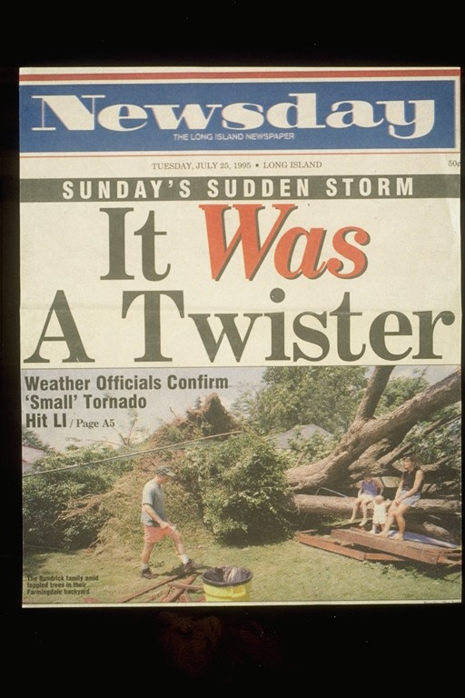
If you think Tornadoes don’t occur on Long Island, think again. This is a photo from Newsday about the aftermath of a F2 Tornado in Farmingdale on July 25th 1995.
- FUJITA TORNADO SCALE:
  - F0 40 to 72 mph light damage
  - F1 73 to 112 mph moderate damage
  - F2 113 to 157 mph considerable damage
  - F3 158 to 206 mph severe damage
  - F4 207 to 260 mph devastating damage
  - F5 261 to 318 mph incredible damage
- Enchanced Fujita Scale -implemented in the U.S. on 1 February 2007, The Enhanced F-scale still is a set of wind estimates (not measurements) based on damage. Its uses three-second gusts estimated at the point of damage based on a judgment of 8 levels of damage to the 28 indicators listed below. These estimates vary with height and exposure. Important: The 3 second gust is not the same wind as in standard surface observations. Standard measurements are taken by weather stations in open exposures, using a directly measured, "one minute mile" speed.
http://www.spc.noaa.gov/faq/tornado/ef-scale.html
FUJITA SCALE |  |  | DERIVED EF SCALE |  | OPERATIONAL EF SCALE
F Number | Fastest 1/4-mile (mph) | 3 Second Gust (mph) | EF Number | 3 Second Gust (mph) | EF Number | 3 Second Gust (mph)
0 | 40-72 | 45-78 | 0 | 65-85 | 0 | 65-85
1 | 73-112 | 79-117 | 1 | 86-109 | 1 | 86-110
2 | 113-157 | 118-161 | 2 | 110-137 | 2 | 111-135
3 | 158-207 | 162-209 | 3 | 138-167 | 3 | 136-165
4 | 208-260 | 210-261 | 4 | 168-199 | 4 | 166-200
5 | 261-318 | 262-317 | 5 | 200-234 | 5 | Over 200
- FUNNEL-CLOUD - a funnel-shaped cloud extending downward from the base of a thunderstorm which is rapidly rotating and does NOT come into contact with the ground or objects on the ground.
- TORNADO - a funnel-shaped cloud extending downward from the base of a severe thunderstorm which is rapidly rotating and comes into contact with the ground or any objects on the ground.
- TORNADO WARNING - issued by your local NWS Forecast Office when a tornado is imminent or occurring. A warning is issued for a county or part of a county and is usually in effect for about an hour.
- TORNADO WATCH - issued by the Storm Prediction Center when severe thunderstorms may produce tornadoes and near the watch area (box). The watch is issued for a large area and is usually in effect for several hours.
- WATERSPOUT - a tornado that occurs over the waters.
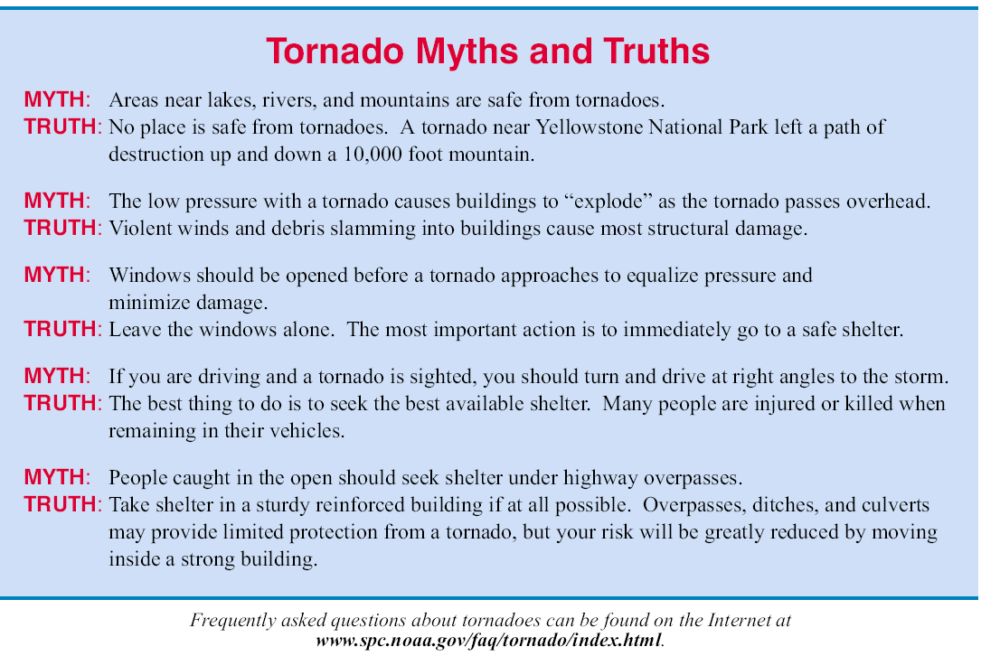

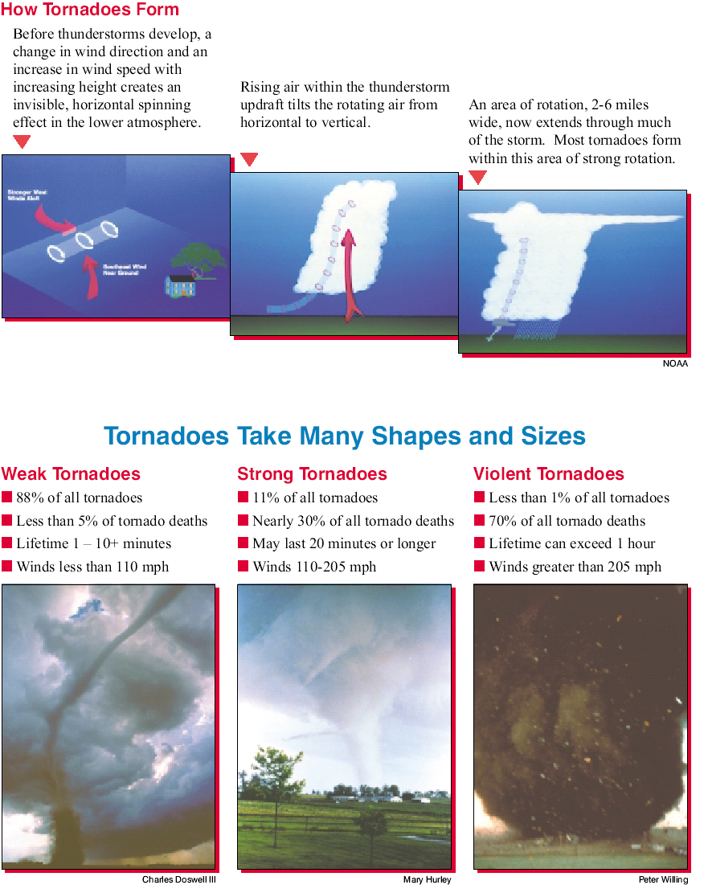

TROPICAL WEATHER

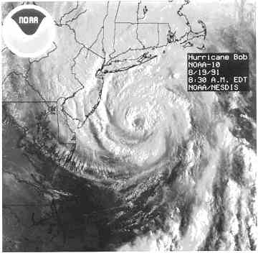
From June 1st through November 30th Long Islanders focus their attention to the Tropics. Several hurricanes have impacted Long Island over the years. The last Hurricane to hit Long Island was Bob in August of 1991. At 830 AM on the 18th, Bob was south of Long Island and had winds of 100 mph. A wind gust of 101 mph was recorded at Montauk Point. (Photo courtesy of NOAA)

HURRICANE - sustained winds of 74 mph, (64kts) (119 km/hr) or greater

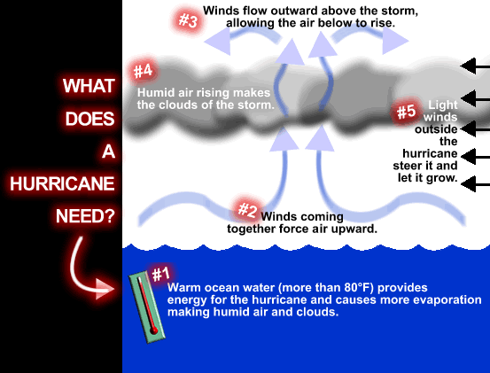
- HURRICANE - sustained winds of 74 mph, (64kts) (119 km/hr) or greater
A tropical cyclone in which the maximum sustained surface wind (using the U.S. 1-minute average) is 64 kts ,74 mph or 119 km/hr or higher. The term hurricane is used for Northern Hemisphere tropical cyclones east of the International Dateline to the Greenwich Meridian. The term typhoon is used for Pacific tropical cyclones north of the Equator west of the International Dateline..
- TROPICAL DEPRESSION - an organized area of low pressure where sustained surface winds are 38 mph (33kts) or less.
- TROPICAL STORM - a strong area of low pressure associated with maximum sustained winds of 39 to 73 mph (34kts to 63kts). It is at this point a tropical cyclone gets a name.
- HURRICANE LOCAL STATEMENT - issued by your local NWS Forecast Office when a hurricane or tropical storm watch or warning is issued for the local area. It contains highly detailed information about present and/or anticipated storm affects such as: watches and/or warnings in effect, storm information, precaution/preparedness information, storm surge and tidal impacts, wind impacts, rainfall and flooding impacts, the tornado threat and update information.
- HURRICANE SEASON - June 1st through November 30th for the Atlantic Ocean, Caribbean Sea & Gulf of Mexico. Peak threat to United States is from the middle of August through late October. Long Island Peak Near the 3rd week of Septmeber.
- HURRICANE WARNING issued by the National Hurricane Center when hurricane conditions are expected in the warning area within 24 hours or less. Complete all storm preparations and evacuate if directed to by local officials.
- HURRICANE WATCH - issued by the National Hurricane Center when hurricane conditions are possible in the watch area generally within 36 hours. This is the time to take action to protect life and property.
- INLAND HIGH WIND WARNING FOR HURRICANE (or TROPICAL STORM) FORCE WINDS - issued by your local NWS Forecast Office, usually in conjunction with a Hurricane (Tropical Storm) Warning issued by the National Hurricane, when hurricane (tropical storm) force winds are expected for inland/non-coastal counties.
- INLAND HIGH WIND WATCH FOR HURRICANE (or TROPICAL STORM) FORCE WINDS - issued by your local NWS Forecast Office, usually in conjunction with a Hurricane (Tropical Storm) Watch issued by the National Hurricane, when hurricane (tropical storm) force winds are possible for inland/non-coastal counties.
- SAFFIR-SIMPSON SCALE: Hurricane Intensity
  - Category 1 74 to 95 mph
  - Category 2 96 to 110 mph
  - Category 3 111 to 130 mph
  - Category 4 131 to 155 mph
  - Category 5 greater than 156 mph
- TROPICAL CYCLONE PUBLIC ADVISORY - issued by the National Hurricane Center. The advisory contains a list of all current watches and warnings on a tropical cyclone. The cyclone position is given in terms of latitude and longitude coordinates and distance from a selected land point or island, as well as the current motion. The advisory includes the maximum sustained winds in miles per hour and the estimated or measured minimum central pressure in millibars and inches. Public advisories are normally issued every six hours. They may be issued every two or three hours when coastal watches or warnings are in effect. Special public advisories may be issued at any time due to significant changes in warnings or in the cyclone. They are broadcast over local NOAA Weather Radio when the tropical storm or hurricane is located west of longitude 50 degrees West.
- TROPICAL DEPRESSION - an organized area of low pressure where sustained surface winds are 38 mph or less.
- TROPICAL STORM - a strong area of low pressure associated with maximum sustained winds of 39 to 73 mph. It is at this point a tropical cyclone gets a name.
- TROPICAL STORM WARNING - issued by the National Hurricane Center when tropical storm conditions are expected in the warning area within 24 hours or less.
- TROPICAL STORM WATCH - issued by the National Hurricane Center when tropical storm conditions are possible in the watch area generally within 36 hours.
- TROPICAL WEATHER OUTLOOK - issued four times a day during the hurricane season by the National Hurricane Center. The outlook is a discussion of significant areas of disturbed weather and their potential for development out to 48 hours.
- TROPICAL WEATHER SUMMARY - issued by the National Hurricane Center. The summary is issued on the first of every month during the hurricane season. It describes the previous month's tropical cyclone activity and gives details on the cyclones as known at that time. The last Tropical Weather Summary of the season gives a brief account of the whole season.

List of Long Island Hurricanes

1825 June 4th a hurricane badly damaged long island
1893 A category 2 hits New York City in late August causing heavy damage
1938 September 21st Long Island express caused storm surge flooding 3 miles inland as a Category 3 in west & central long island. Reports of a 40ft wall of water destroyed approx 14,000 homes. 500 killed
1944 A Category 1 hits Long Island between Westhampton and Southampton on September 15th.
1954 August 31, Hurricane Carol hits Long Island as many homes were splintered by gusts to 130mph
1960 September 12th Hurricane Donna hits Central Long Island with gusts to 125mph, sustained at 100mph on eastern end

1961 Hurricane Esther Clipped Eastern Long Island, with heavy rain and strong winds. 108 mph at Montauk, 100 mph Fire Island
1976 Belle hits Aug 10th peak gust 95mph system was weakening 24 hrs prior to landfall with a forward speed of up to 25mph.
1985 Hurricane Gloria gives area gusts to 115mph shuts down NYSE area reported many pre mature births due to low pressure. Low tide at landfall may have saved many lives. (Moderate damage)
1991 Hurricane Bob brushes Long Island, 101 mph wind gust at Montauk Point. 5 to 8 Inches of rain fell on Long Island. Areas of the Northeast suffered the worst damage up to 1.5 billion dollars in damage. 18 Killed

Many Tropical Storms have also affected Long Island and caused millions of dollars in Damage.

What Should I Do?
BEFORE HURRICANE SEASON STARTS
- Plan an evacuation route.
  - Contact the local emergency management office or American Red Cross chapter, and ask for the community hurricane preparedness plan. This plan should include information on the safest evacuation routes and nearby shelters.
- Learn safe routes inland.
  - Be ready to drive 20 to 50 miles inland to locate a safe place.
  - Have disaster supplies on hand.
  - Flashlight and extra batteries
  - Portable, battery-operated radio and extra batteries
  - First aid kit and manual
  - Emergency food and water
  - Non-electric can opener
  - Essential medicines
  - Cash and credit cards
  - Sturdy shoes
- Make arrangements for pets.
  - Pets may not be allowed into emergency shelters for health and space reasons.
  - Contact your local humane society for information on local animal shelters.
- Make sure that all family members know how to respond after a hurricane.
  - Teach family members how and when to turn off gas, electricity, and water.
  - Teach children how and when to call 9-1-1, police, or fire department and which radio station to tune to for emergency information.
- Protect your windows.
  - Permanent shutters are the best protection. A lower-cost approach is to put up plywood panels. Use 1/2 inch plywood - marine plywood is best - cut to fit each window. Remember to mark which board fits which window.
  - Pre-drill holes every 18 inches for screws. Do this long before the storm.
- Trim back dead or weak branches from trees.
- Check into flood insurance.
  - You can find out about the National Flood Insurance Program through your local insurance agent or emergency management office. There is normally a 30-day waiting period before a new policy becomes effective.
  - Homeowners polices do not cover damage from the flooding that accompanies a hurricane.
- Develop an emergency communication plan.
  - In case family members are separated from one another during a disaster (a real possibility during the day when adults are at work and children are at school), have a plan for getting back together.
  - Ask an out-of-state relative or friend to serve as the "family contact." After a disaster, it's often easier to call long distance. Make sure everyone in the family knows the name, address, and phone number of the contact person.
DURING A HURRICANE WATCH
(A Hurricane Watch is issued when there is a threat of hurricane conditions within 24-36 hours.)
- Listen to a battery-operated radio or television for hurricane progress reports.
- Check emergency supplies.
- Fuel car.
- Bring in outdoor objects such as lawn furniture, toys, and garden tools and anchor objects that cannot be brought inside.
- Secure buildings by closing and boarding up windows. Remove outside antennas.
- Turn refrigerator and freezer to coldest settings. Open only when absolutely necessary and close quickly.
- Store drinking water in clean bathtubs, jugs, bottles, and cooking utensils.
- Store valuables and personal papers in a waterproof container on the highest level of your home.
- Review evacuation plan.
- Moor boat securely or move it to a designated safe place. Use rope or chain to secure boat to trailer. Use tiedowns to anchor trailer to the ground or house.
DURING A HURRICANE WARNING
(A Hurricane Warning is issued when hurricane conditions (winds of 74 miles per hour or greater, or dangerously high water and rough seas) are expected in 24 hours or less.)
- Listen constantly to a battery-operated radio or television for official instructions.
- If in a mobile home, check tiedowns and evacuate immediately.
- Avoid elevators.
- If at home:
  - Stay inside, away from windows, skylights, and glass doors.
  - Keep a supply of flashlights and extra batteries handy. Avoid open flames, such as candles and kerosene lamps, as a source of light.
  - If power is lost, turn off major appliances to reduce power "surge" when electricity is restored.
- If officials indicate evacuation is necessary:
  - Leave as soon as possible. Avoid flooded roads and watch for washed-out bridges.
  - Secure your home by unplugging appliances and turning off electricity and the main water valve.
  - Tell someone outside of the storm area where you are going.
  - If time permits, and you live in an identified surge zone, elevate furniture to protect it from flooding or better yet, move it to a higher floor.
  - Take pre-assembled emergency supplies, warm protective clothing, blankets and sleeping bags to shelter.
  - Lock up home and leave.
AFTER THE STORM
- Stay tuned to local radio for information.
- Help injured or trapped persons.
- Give first aid where appropriate.
- Do not move seriously injured persons unless they are in immediate danger of further injury. Call for help.
- Return home only after authorities advise that it is safe to do so.
- Avoid loose or dangling power lines and report them immediately to the power company, police, or fire department.
- Enter your home with caution. Beware of snakes, insects, and animals driven to higher ground by flood water.
- Open windows and doors to ventilate and dry your home.
- Check refrigerated foods for spoilage.
- Take pictures of the damage, both to the house and its contents for insurance claims.
- Drive only if absolutely necessary and avoid flooded roads and washed-out bridges.
- Use telephone only for emergency calls.
- INSPECTING UTILITIES IN A DAMAGED HOME
  - Check for gas leaks--If you smell gas or hear blowing or hissing noise, open a window and quickly leave the building. Turn off the gas at the outside main valve if you can and call the gas company from a neighbor's home. If you turn off the gas for any reason, it must be turned back on by a professional.
  - Look for electrical system damage--If you see sparks or broken or frayed wires, or if you smell hot insulation, turn off the electricity at the main fuse box or circuit breaker. If you have to step in water to get to the fuse box or circuit breaker, call an electrician first for advice.
  - Check for sewage and water lines damage--If you suspect sewage lines are damaged avoid using the toilets and call a plumber. If water pipes are damaged, contact the water company and avoid the water from the tap. You can obtain safe water by melting ice cubes.

Hurricane Information Links
FEMA Page about Hurricanes | http://www.fema.gov/hazards/hurricanes/
Hurricane Tracking Chart:  Easy to Print | http://www.nhc.noaa.gov/AT_  Track_chart2.pdf
National Hurricane Center | http://www.nhc.noaa.gov
National Weather Service  Hurricane Page | http://www.nws.noaa.gov/om/hurricane  /index.shtml
Hurricane Brochures | http://www.nws.noaa.gov/om/brochures  /hurr.pdf
National Weather Service  Weather Guide | http://www.nws.noaa.gov/om/  brochures/ttl.pdf
Hurricane Disaster Page from  Red Cross | http://www.redcross.org/services/  disaster/0,1082,0_587_,00.html
Hurricanes | http://hurricanes.noaa.gov/
2007 Hurricane Outlook | http://www.cpc.ncep.noaa.gov/products/outlooks/hurricane.shtml
New York State Emergency Management | http://www.semo.state.ny.us/
NYSEM-Hurricanes | http://www.semo.state.ny.us/info/publicsafety/hurricaneprepare.cfm
Storm Prediction Center | http://www.spc.noaa.gov/
LI Hurricanes | http://www.bnl.gov/weather/files/Hurricane/LI_hurricanes.htm

